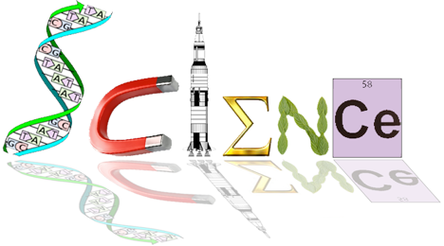

**ATHBY**

**Task 1: Endocrine and Nervous System and Homeostasis Test**

**Multiple Choice Section: (14 marks)**

1. The cerebral cortex is mainly concerned with which of the following?
2. connecting the left and right hemispheres
3. conscious sensory awareness and voluntary movement
4. control of the endocrine system
5. control of both the parasympathetic and sympathetic nervous systems
6. People who have suffered physical damage to the cerebellum would be expected to show symptoms such as:
7. a low intelligence
8. uncoordinated jerky movements
9. a lack of autonomic nervous system functioning
10. no memory
11. The effectors associated with negative feedback models include:
12. the nervous and endocrine systems
13. the body fluids
14. glands and muscles
15. all body tissues
16. When the hormone cortisol reaches a target cell, it enters the cell and combines with a receptor protein inside the cell. The combined substance enters the nucleus, where it activates genes to produce a protein. Thus, cortisol is a:
17. water soluble amine
18. water soluble steroid
19. lipid soluble amine
20. lipid soluble steroid
21. At resting potential, the ion distribution inside and outside of a neuron is such that __________ ions are most abundant on the outside of the cell, while __________ ions are most abundant on the inside of the cell.
22. potassium; sodium
23. sodium; potassium
24. calcium; phosphate
25. sulfate; potassium

Question 6 refers to the graph below

Antidiuretic hormone is important in controlling water balance. The graph shows changes in the concentration of antidiuretic hormone as plasma solute concentration changes.



1. The change in antidiuretic hormone in the blood plasma at 285 mOs/kg was due to
   1. an increase in osmotic pressure in the cells
   2. a decrease in the solute concentration of the plasma
   3. an increased intake of water into the cells
   4. a decrease in osmotic pressure in the plasma
2. Aldosterone is a hormone found in the **adrenal medulla** which acts on the **liver** to increase the amount of sodium. The statement would be correct if some or all of the words in bold were replaced with these words
   1. adrenal cortex and kidney
   2. kidney and decrease
   3. adrenal cortex, kidney, decrease and potassium
   4. adrenal cortex, kidney and decrease
3. Which of the following statements concerning the control of blood gases is correct?
   1. The carbon dioxide concentration produces the most immediate effect.
   2. The carotid and aortic bodies respond rapidly to the blood oxygen concentration.
   3. Hydrogen ion receptors are found only in the carotid artery.
   4. A more rapid rate of breathing is produced when the hydrogen ion concentration increases.
4. Which of the below hormones can directly promote physiological responses to help LOWER blood glucose levels?
   1. Thyroid Regulating Hormone (TRH), Prolactin, Thyroxine
   2. Adrenaline, TSH, ACTH
   3. Cortisol, Calcitonin, Oestrogen
   4. Thyroxine, Cortisol, Adrenaline
5. After a meal of fish and chips with lots of salt which of the following would be true?
   1. More sodium would be present in the urine
   2. The secretion of aldosterone from the adrenal cortex would decrease
   3. The secretion of adrenalin from the adrenal cortex would decrease
   4. Both (a) and (b) above
6. After a series of deep inhalations and exhalations (i.e. forced breathing) there is a period of reduced breathing rate because the

a) nitrogen concentration of the blood has increased

b) CO2 concentration of the blood has increased

c) CO2 concentration of the blood has decreased

d) O2 concentration of the blood has decreased

1. After running hundreds of metres an athlete continues to breathe hard for some minutes because

a) the high level of oxygen in the blood stimulates the cardiovascular centre to increase the breathing rate

b) the low level of bicarbonate ions in the blood stimulates receptors in the carotid and aortic bodies to increase the breathing rate

c) the high level of carbon dioxide in the blood stimulates the receptors in the medulla increase the breathing rate

d) he needs to lower down the body temperature because of the excess heat

1. If a drug completely destroyed the cells of a man’s pancreas, we would expect to find a

a) high concentration of glucose in his blood and in his urine

b) normal concentration of glucose in his blood and a high concentration in his urine

c) high concentration of glucose in his blood, but low concentration in his urine

d) low concentration of glucose in both blood and urine

1. When glucose molecules are chemically combined in long chains to form glycogen the process is known as

a) gluconeogenesis

b) glycogenolysis

c) respiration

d) glycogenesis

**YEAR 12 ATAR HUMAN BIOLOGY**

**Task 2: Endocrine, Nervous and Homeostasis Test**

**NAME:_____________________________**

**TEACHER:__________________________**

**DATE:______________________________**

**Multiple choice section**

Answer all questions by placing an X over the most correct answer on the multiple choice answer sheet.

1. a b c d 11. a b c d

2. a b c d 12. a b c d

3. a b c d 13. a b c d

4. a b c d 14. a b c d

5. a b c d

6. a b c d

7. a b c d

8. a b c d

9. a b c d

10. a b c d

SCORES:

MC: /14

SA: /34

EA: /16

TOTAL: /64

_______ %

**Short Answer: 34 marks**

21a) Provide one difference between the Autonomic and Somatic Nervous System divisions. (1 marks)

________________________________________________________________________________________________________________________________________________________________________________________________________________________________________________________________________________________________________________________________

One of the types of neurons involved in the reflex arc is classified as pseudounipolar.

The diagram below shows the general structure of a pseudounipolar neuron.



b) Name the type of neuron that is pseudounipolar and explain why it is classified as

pseudounipolar (2 marks)

________________________________________________________________________________________________________________________________________________________________________________________________________________________________________________

22. The diagram below shows the relationship between the hypothalamus and the pituitary gland.





a) Describe the process leading to secretion of hormones from the anterior lobe into the bloodstream. (3 marks)

________________________________________________________________________________________________________________________________________________________________________________________________________________________________________________________________________________________________________________________________________________________________________________________________________________

b) Explain why the posterior lobe is not considered to be a true endocrine gland. (2 marks)

________________________________________________________________________________________________________________________________________________________________________________________________________________________________________________________________________________________________________________________________

c) Use the two hormones released by the anterior lobe of the pituitary gland to complete the following table. (2 marks)

|  |  |  |
| --- | --- | --- |
| **Hormone** | **Target Cells/Organ** | **Function** |
| **Adrenocorticotrophic**  **hormone (ACTH)** |  |  |
| **Luteinizing hormone**  **(LH)** |  |  |

23. Refer to the following diagram for question 23.



a) Alzheimer’s disease is a form of dementia that can cause memory loss, confusion and mood swings. Given these symptoms of Alzheimer’s disease, which part of the brain (labelled A-D) above would you expect to be most affected by this disease? (1 mark)

________________________________________________________________________________

b) Although different diseases, Alzheimer’s disease and Parkinson’s disease are similar in that they both affect the brain. There are also similarities in the causes and effects of these diseases.   
State one such similarity between Alzheimer’s disease and Parkinson’s disease. (1 mark)

________________________________________________________________________________________________________________________________________________________________

c) The nervous and endocrine systems work together to coordinate functions of all body systems. However, they differ in several ways.

Complete the table below to outline three of these differences. (3 marks)

|  |  |  |
| --- | --- | --- |
| **Characteristic** | **Nervous System** | **Endocrine System** |
| Speed of action |  |  |
| Duration of action |  |  |
| Specificity of message |  |  |

d) Tabun is an extremely toxic synthetic organophosphorus compound. It is a clear, colourless, and tasteless liquid with a faint fruity odour. It is classified as a nerve agent because it fatally interferes with normal functioning of the mammalian nervous system. Using your knowledge of the functions of the nervous system, complete the table below by identifying where the dysfunction would most likely have occurred to bring about the stated symptoms. Provide a scientific reason for your choice. (6 marks)

|  |  |  |
| --- | --- | --- |
| **Tabun Symptoms** | **Structure/s of the nervous system affected** | **Reason** |
| Excessive sweating |  |  |
| Respiratory failure |  |  |
| Blurred vision |  |  |

Refer to the diagram below to answer question 24.

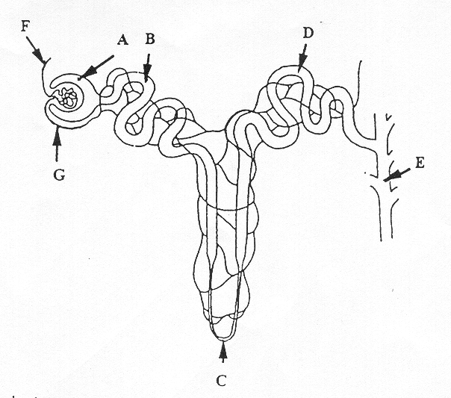

24. a) Name the two hormones that act on BOTH parts C and D. State where they are produced and describe their function. (6 marks)

i)_______________________________________________________________________________________________________________________________________________________________________________________________________________________________________________

ii)_______________________________________________________________________________________________________________________________________________________________________________________________________________________________________________

b) Explain how one of the hormones you identified in part (a) is regulated. (3 marks)

________________________________________________________________________________________________________________________________________________________________________________________________________________________________________________________________________________________________________________________________________________________________________________________________________________

25. Complete the following table on the feedback loop. (6 marks)

|  |  |
| --- | --- |
| **Component** | **Description** |
|  | A change in the environment that causes or could cause a physiological change away from homeostatic tolerance parameters |
| Receptor |  |
|  | Manages the physiological or behavioural response |
| Effector |  |
|  | The actions carried out by systems/organs/tissues to return to homeostasis |
| Feedback |  |

**Extended Answer: 16 marks**

Answer each part of the following question on the line paper provided. Responses could include clearly labelled tables and graphs; clearly labelled diagrams with explanatory notes; lists of points with linking sentences and annotated flow diagrams with introductory notes.

The nervous and endocrine systems are both involved in the maintenance of the body’s internal environment within tolerance limits. One example of this is thermoregulation (that is, the maintenance of internal body temperature).

a) Explain how the nervous and endocrine systems maintain the body’s internal temperature when it is in danger of falling below the tolerance limits. Ensure your answer includes **two** nervous mechanisms and **one** endocrine mechanism. (10 marks)

b) Thermoregulation can also be assisted by behavioural mechanisms. Identify **three** behaviours that lower internal temperature when it is in danger of rising above tolerance limits and outline how each of these assists in maintaining internal temperature. (6 marks)

________________________________________________________________________________________________________________________________________________________________________________________________________________________________________________________________________________________________________________________________________________________________________________________________________________

________________________________________________________________________________________________________________________________________________________________________________________________________________________________________________________________________________________________________________________________________________________________________________________________________________

________________________________________________________________________________________________________________________________________________________________________________________________________________________________________________________________________________________________________________________________________________________________________________________________________________

________________________________________________________________________________________________________________________________________________________________________________________________________________________________________________________________________________________________________________________________________________________________________________________________________________________________________________________________________________________________________________________________________________________________________________________________________________________________________________________________________________________________________________________________________________________________________________________________________________________________________________________________________________________________________________________________________________________________________________________________________________________________________________________________________________________________________________________________________________________________________________________________________________________________________________________________________________________________________________________________________________________________________________________________________________________________________________________________________________________________________________________________________________________________________________________________________________________________________________________________________________________________________________________________________________________________________________________________________________________________________________________________________________________________________________________________________________________________________________________________________________________________________________________________________________________________________________________________________________________________________________________________________________________________________________________________________________________________________________________________________________________________________________________________________________________________________________________________________________________________________________________________________________________________________________________________________________________________________________________________________________________________________________________________________________________________________________________________________________________________________________________________________________________________________________________________________________________________________________________________________________________________________________________________________________________________________________________________________________________________